**CubeSat Sun Vector Determination Options**

**Overview**

Sun vector data is necessary for attitude determination algorithms such as TRIAD and solar pointing which maneuver satellite around for power generation and signal transmission. Purchasing a sun sensor to compute the sun vector can be costly and difficult due to tight mass and volume constraints required by CubeSat systems. Alternative solutions can be built or use existing components to generate the sun vector, including: photodiode sun sensors and coarse sun sensing using solar panels [1].

**Photodiode Sun Sensors**

Photodiode sun sensors use a box containing an array of photodiodes and with a slit on top. Light enters through the slit (similar to a camera pinhole model) and by using the geometry of the box and which photodiodes come into contact with light, the angle can be determined. The sensor has a wide 90-degree field-of-view. However, each sensor only covers one axis of determination, thus for three are required for operation. Requirements for the dimensions of the device are shown below.

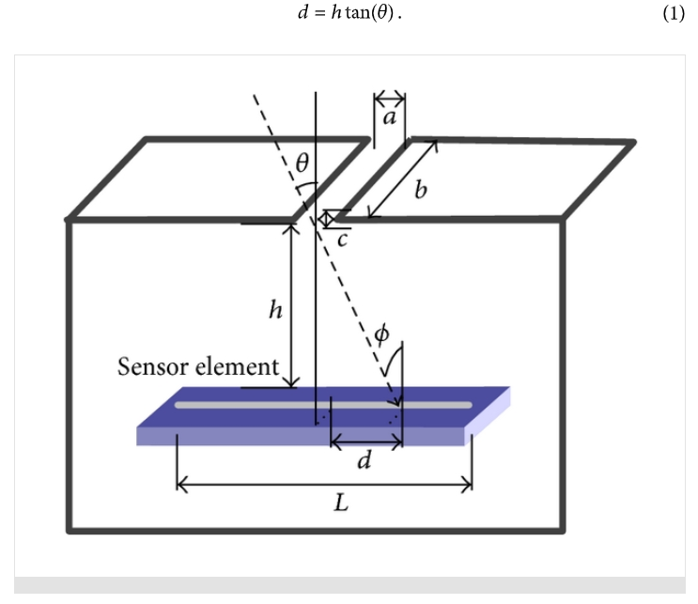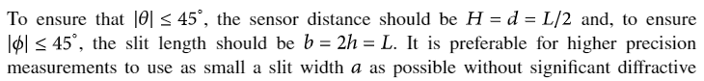

**Accuracy of Photodiode Sun Sensors**

For measurement purposes, the device was placed on a gimbal and rotated around a light source at various angles. The experiment does not account for additional sources of light (ex., Earth’s Albedo) and angles for other axes. A distribution of photodiode activation values is produced and the centroid is taken to account for *d*, distance across the array. Above formula used for angle determination.

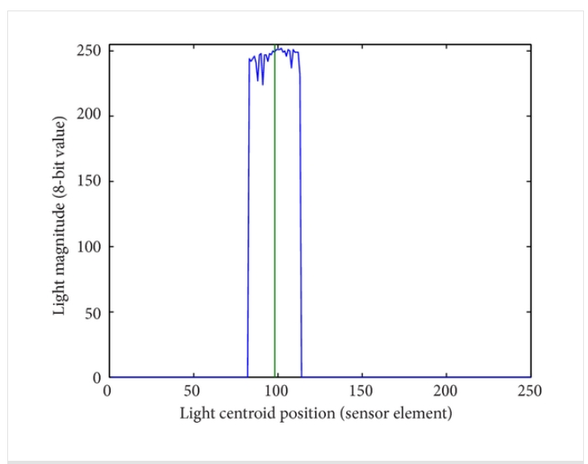, 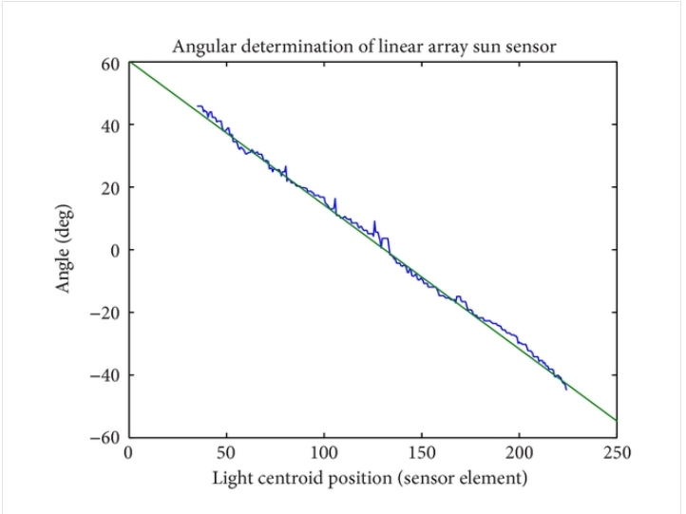

A plot of estimated versus actual solar angle is then shown; minimal variance of about 3-5 degrees.

**Coarse Sun Sensing using Solar Panels**

Two different types of setups can be used to determine sun vector using solar panels, however neither effectively accounts for additional sources of light (ex., Earth’s Albedo).

One method employs determining which quadrant of satellite’s body frame light is coming from. The amount of current per each solar panel (in positive x, positive y, and negative y directions) is compared. Depending on an inequality that determines which panel generates the highest current, a different formula is used to determine the angle per that axis.

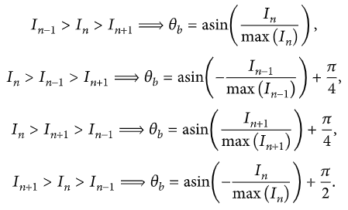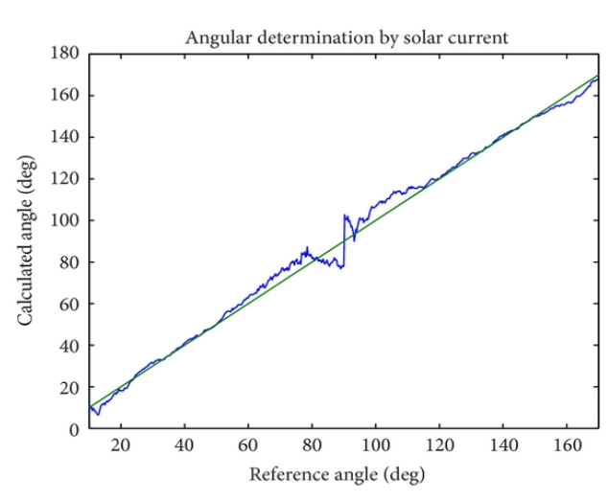

According to results generated from an experiment which rotated the device using a gimble, the variance in angular determination versus true angle is higher, especially near the range 90 – 120 degrees. This is due to the mapping equations used to determine sun angles relative to body frame. Overall this solar panel configuration generates a variance of 7 degrees.

Another method uses a similar approach, however simplifies analysis by comparing generated current to maximum current output per each solar panel. Then to account for which faces the panels are located on, it uses a variable *n* that indicates whether panel faces positive or negative axis direction.

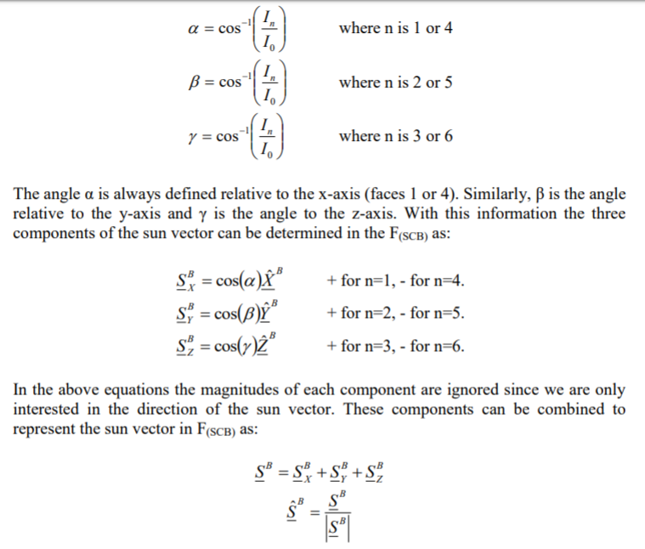

The sun vector relative to the body frame is computed and can be fed into Simulink model for testing purposes.

**Mitigating Effects of Albedo**

Earth’s albedo reflects some sunlight back, causing CubeSat to pick up on incident rays that are not from the Sun. For sun-pointing algorithms this is problematic as it can cause the satellite to incorrectly position itself and not generate enough power.

Earth’s albedo varies depending on the visible surface of the Earth and amount of clouds over it. Using the known height of the satellite from Earth, it is possible to determine the field-of-view angle that Earth covers satellite with.

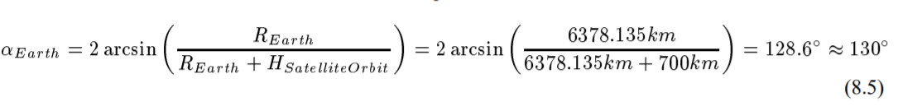

Surface area providing light causes coarse sun sensor to detect albedo from many angles, whereas input from Sun will be from a single angle. However, the satellite cannot differentiate between light coming in from the Earth or the Sun. Keep in mind that due to albedo, 30% of light absorbed by solar panels is from Earth, however depending on satellite’s orientation this effect can be reduced.

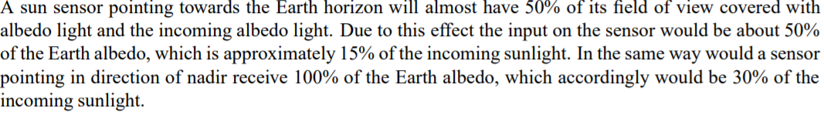

Therefore by calculating an initial sun vector, its direction can be compared against nadir vector to determine Albedo effects and a correction algorithm can be applied depending on the test-case [2].

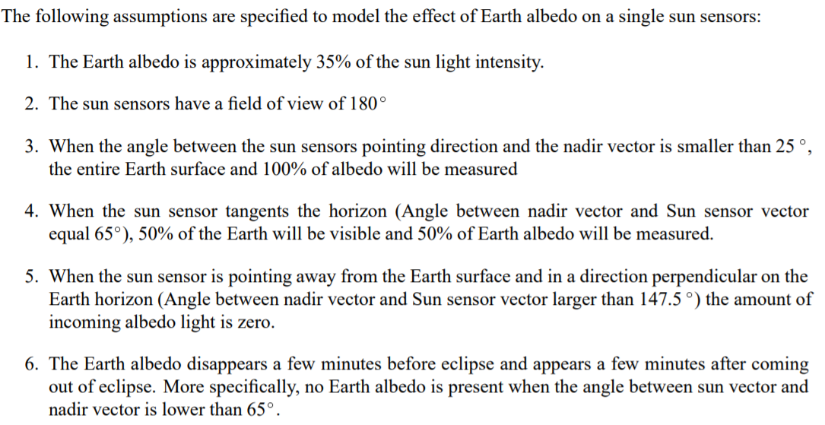

**Albedo Correction**

Earth albedo gets added to sun vector and used for attitude determination. To do this, a nadir-vector is found using orbit simulation (dependent on where satellite is, time), it is scaled by 30% of length of sun vector, and added to sun vector. Effects of albedo correction depending on orbit can be summarised as:

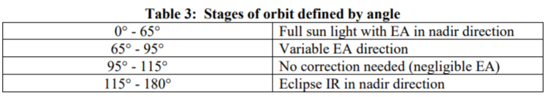

According to Matlab simulations, the variance in angle gets reduced from 20-degrees to 10-degrees after adding in albedo correction.

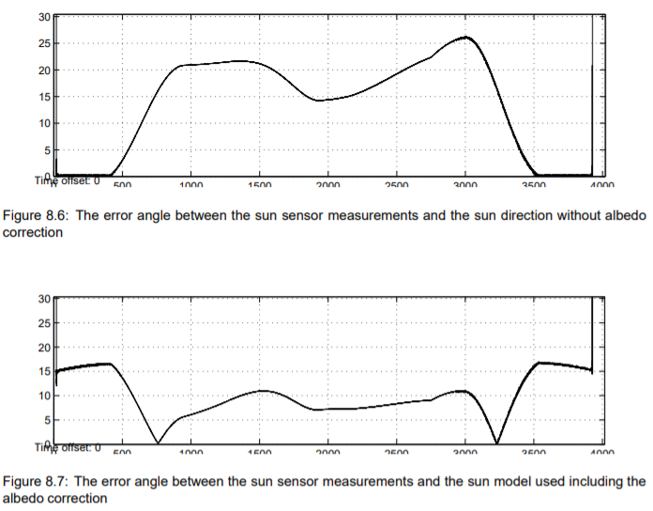

**Comparison to Industry Grade Sun Sensors**

Typical sun sensors achieve an accuracy of 0.0005 to 4 degrees [3], according to methods shown variance can range from 5 to 20 degrees (in worst-case without any correction algorithm). Comparatively this is a good start to begin experiments from.

**Matlab Simulation**

Possibly use a gimble setup with solar cells placed on a box that is scaled down from CubeSat. Rotate the gimble for various sun-angles, collect data and compare.

**Matlab Script for Albedo Correction (so far)**

A = 29/100^2 %solar panel area (m^2)

eff = 0.24 %solar panel efficiency

K = 1380 %solar irradiance (W/m^2)

I0 = 4 * A * K * cosd(0) * eff %assuming 4 cells per panel -> 3.84W max

nadir = [5 4 3] %estimate for nadir vector for Albedo correction

%Coordinate vector defn

Xb = [1 0 0];

Yb = [0 1 0];

Zb = [0 0 1];

%Input current per each panel (assuming upto 6)

I = input('Input as [I1, I2, I3, I4, I5, I6]: ');

%Calculate alpha, beta, delta angles relative to each axis

%If solar panel in neg direction detects light, take angle relative to

%opposite side

%Else solar panel in pos direction detects light, take angle normally

if I(1)==0

alpha = 180 - acosd(I(4)/I0);

else

alpha = acosd(I(1)/I0);

end

if I(2)==0

beta = 180 - acosd(I(5)/I0);

else

beta = acosd(I(2)/I0);

end

if I(3)==0

gamma = 180 - acosd(I(6)/I0);

else

gamma = acosd(I(3)/I0);

end

Sb = [cosd(alpha) cosd(beta) cosd(gamma)];

disp(Sb)

%Check if albedo correction required by computing angle between sun sensor

%and nadir vector

%Accounts for field-of-view of albedo effect

if atan2d(norm(cross(Sb, nadir)), dot(Sb, nadir)) < 95

%albedo correction requires nadir-vec to be 30% of sun-vec magnitude

nadir_mag = norm(Sb) * 0.3;

%scale nadir vec by required magnitude

nadir_unit = nadir / norm(nadir);

nadir_correction = nadir_unit * nadir_mag;

%corrected sun-vector

Sb = Sb + nadir_correction;

else

end

**References**

1. Post, A.M., Lee, R. A Low-Cost Photodiode Sun Sensor for CubeSat and Planetary Microrover. December 17, 2013. <https://www.hindawi.com/journals/ijae/2013/549080/#EEq6>.
2. Krogh, K., Schreder E. Attitude Determination for AAU CubeSat. June 6, 2002. <http://www.amsat.org.ar/cubesat/aauACSD.pdf>.
3. Gaebler J. Coarse Sun Sensing for Attitude Determination of CubeSat. Spring 2007. <https://ufdc.ufl.edu/AA00062245/00001>.